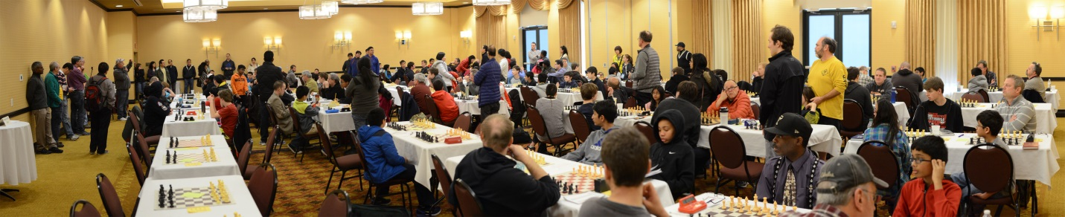

2016 Cardinal Report

By Grant Neilley

183 players from 13 states and 2 Canadian provinces gathered in Columbus for the 39th Annual Cardinal Open, held for the fourth consecutive year at the beautiful Embassy Suites Airport Hotel. The field included 2 GMs, 2 IMs, and IM-elect Awonder Liang, the youngest person ever in the US to attain that title. Kelly Bloomfield provided eight DGT boards which were spread throughout the top four sections to project games outside the playing hall and online. TDs were Grant Neilley, Myron Thomas, and Will Thomas, joined by Tom Priest in the Blitz tournament.

In the Open section, five players tied for first with four points each, including Ohio’s own FM Carl Boor, along with GM Miktov, IMs Bora and Vojinovic, and young Mr. Liang. They shared the first through fourth places prizes winning $580 each, and Awonder earned the $100 bonus for first on tie-breaks. Taking the U2300 class prize with 3.5 points each were Ryan Clayton and George Umezinwa of Ohio, and Rohan Talukdar of Ontario. Yuri Barnakov took the upset prize.

In U2100, Surya Parasuraman (MI) took clear first with 4.5, followed closely by Thomas Friske (IN) and Stanely Cao (OH) with 4.0 each. The Fourth place prize was shared in a 5-way tie by William Moriss (OH), Benjamin Stern (IL), Akash Narayanan (MI), Felix McCain (VA) and Elton Cao (OH). James Antoline (OH) took the upset prize.

In U1800, Jim Slagle (OH and Brandon O’Neil (MI) shared first place with 4.5 each. Buckeyes James Lake and Evan Huang shared second with 4 points. Evan Park of PA took the upset prize, and in fact claimed *three* of the largest upsets in the section.

In U1500, Ms. Stella Huang took first place with the only perfect 5.0 score of the tournament. Coming in second with 4.0 were Quentin Docter (OH), Ben Foley (IN) and Eric Blum (OH). Bruce Hill (OH) won the upset prize.

And finally, in U1200 Ohioan Jonathan Rissing took clear first with 4.5 point, followed at 4 points each by Ken Brown (IN), Ronald Storn (OH) and Edison Liu (OH). Don Calpin took the upset prize.

A new feature this year was the offer of a prize to the top scoring female over the entire event. As a class prize, ladies winning larger place prizes weren’t eligible, and it was claimed by Columbus player Kathy Lin with 3.5 points in the U1500 section.

The Saturday evening blitz had a large field of 26 players and was FIDE rated for the first time. Carl Boor took first place with a perfect 10 points, followed by Naphtali Smith with 8 and Casey O’Melia with 7.5, Ohioans all. Nabil Feliachi (PA) took the U2000 first place prize with 6.5, with second place shared by David Demetruck and Aleks Vayntraub, both of Ohio. A U1700 prize went to Anthony Francis (PA), and U1400 to Sulyama Chapelle.

2016 was the second year for the Jr. Cardinal which was restricted to K-12 players rated under 1300, and played at a time control of G/75 over two days. Participation doubled to 23, and first place was shared by four players with 4 points each: Abinav Dinesh, Edward Zha, Mihir Vador and Jaswanth Vandrasi. U1100 prizes went to Yuvraj Tammina for first, and Uku Hughes and James Marinas tied for second. Aditya Anand won the U900 prize.